Table of Contents
1 Architectural view model 3
1.1 The logical view 3
1.2 The Physical view 3
1.3 The Development view 4
1.4 The Process view 4
1.5 The Scenarios (or use case view) 4
2 Architectural guidelines 5
2.1 Loosely coupled architecture 5
2.2 Asynchronous component communication 5
3 The Deployment view 6
3.1 Software artifacts 6
3.1.1 Folder structure 6
3.1.2 Github 6
3.1.3 Music sources 7
3.1.4 Self-documenting python code. 7
3.2 Target environment 8
3.3 Software installation 9
3.3.1 Development: install script 9
3.3.2 Production 9
3.4 Runtime 9
3.5 Configuration 9
3.6 System services 9
3.7 Plugins 10
3.7.1 Project structure 11
3.7.2 Plugin base class 11
3.7.3 Dynamic Plugin loading 11
3.7.4 life-cycle handler 12
4 The Logical view: Class diagrams 13
4.1 Introduction on Class diagrams 13
4.1.1 UML class notation 13
4.1.2 UML Class relationships 14
4.2 The top level diagram 16
4.3 Messaging 17
4.4 Remote Monitoring Service 19
4.5 USB Service 20
4.6 Wifi Service 21
4.7 Logging 23
4.7.1 Logging introduction 23
4.7.2 Logging design choices 23
4.7.3 Loggers 24
4.7.4 Queue handling 24
4.7.5 Fallback loggers 25
4.7.6 LogHealthMonitor 25
4.7.7 Filter 25
4.7.8 Formatter 25
4.7.9 Linux Logrotate service 26
4.7.10 LogHealthMonitor 26
4.7.11 Class diagram 27
4.7.11.1 faulthandler 28
4.7.11.2 SafeLogger class 28
4.7.11.3 StrictLogHandler 28
4.7.11.4 logging.Handler 28
4.7.11.5 logging.Logger 28
4.7.11.6 ColorFormatter 29
4.7.11.7 uvicorn integration 29
5 The Logical view: State diagrams 30
5.1 Maincontrol state 30
5.2 Oradio Control States 31
5.3 Access Point state control 32
5.4 PluginManager State control 33
6 The Physical view: Component diagrams 35
6.1 OS Service 35
6.2 Messaging (Commands) 36
6.3 Music Players 37
6.4 GPIO components 38
7 The Process view: Sequence diagrams 39
7.1 Messaging 39
8 The scenario view: use case diagrams 40

Architectural view model
The architecture 4+1 views are used to describing the software systems based on different viewpoints, to discover if the architecture fulfills the needs of the different stakeholders. The views will be presented using the Unified Modeling Language (UML) tool
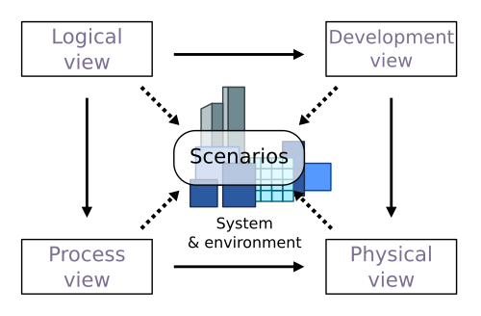
llibre

The logical view
The Logical View, often referred to as the “Class Diagram”. It focuses on the static structure of the system. This view deals with the essential components of the system, such as classes, objects, relationships, and their attributes. Class diagrams visually represent the classes and their associations in the system, to understand how various components interact with one another. This view provides insights into the overall design and organization of the system’s functionality.
Related UML diagrams:
- Class diagrams
- Component diagram

The Physical view
It concerns the topology of the software components on the physical infrastructure as well as the physical connections between components. It includes details about servers, nodes, and their interconnections, including defining the communication protocols This view ensures that the system architecture aligns with the physical constraints and requirements.
Related UML diagrams:
- Class diagrams
- State diagrams
- Component diagrams

The Development view
The system from the perspective of the programmers (or the implementation view) and is concerned with software management. It maps the logical design to physical code organization, clarifies module boundaries, dependencies, and re-usability.

The Process view
The dynamic aspects of the system, explains the system processes and how they communicate. Models the dynamic behavior, execution flow, threading, synchronization, performance, and fault tolerance.
Related UML diagrams:
- Sequence diagrams,
- Activity diagrams
- State diagrams

The Scenarios (or use case view)
It captures what the system does from an end-user perspective. The description of an architecture is illustrated using a small set of use case, or scenarios, which become a fifth view. The scenarios describe sequences of interactions between objects and between processes. They are used to identify architectural elements and to illustrate and validate the architecture design.
Related UML diagrams:
- Use Case diagram

Architectural guidelines

Loosely coupled architecture
The architecture should follow the guidelines for loosely coupled architecture. A loosely coupled architecture is a design principle in which system components are weakly associated. This means that each component can operate independently, allowing for greater flexibility in system design and maintenance.
Key characteristics:
- Changes made to one component have minimal impact on others, which enhances the overall resilience of the system
- Each component has little or no knowledge of the internal workings of other components.
- Systems can scale more easily as components can be modified or replaced independently.
- Each component can be developed, deployed, tested and maintained independently

Asynchronous component communication
A loosely coupled architecture using a queue allows different components of a system to communicate asynchronously, meaning they can operate independently without being directly connected.
The component communication uses the publish/subscriber model, in which a communication queue will be assigned to each of the subscribers. When a new message is published, the related message Topic will be distributed to the assigned subscribers queue.
Key characteristics:
- Independence: Producers and consumers don’t need to know about each other. They only interact with the queue, reducing direct dependencies.
- Failure isolation: If one component fails, the queue allows other components to continue functioning. This isolation minimizes the impact of failures on the overall system.
- Asynchronous Communication: Components can communicate without waiting for each other to respond, which reduces downtime and improves responsiveness.
- Buffering: They act as buffers that store messages until the receiving service is ready to process them. This helps manage varying loads and prevents service overload

The Deployment view

Software artifacts

Folder structure
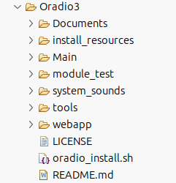
The folder structure of the Oradio project :
- Documents: for design documentation
- install_resources: resources related to configuration files, system service file, shell scripts required for installation of Oradio project.
- Main: the python modules
- module_test: module test python programs
- system_sounds: sound files (wav) for system related sound (e.g. click.wav for touch button click sound)
- tools: shell scripts
- webapp: resources required for the web-interface.
- LICENSE: The GNU general public license, which is is required to include to inform users of their rights and obligations regarding the software. This ensures proper attribution and compliance with the terms of the license.
- oradio_install.sh: install script to install a fresh Oradio project from scratch
- README.md: install instructions

Github
GitHub is a cloud-based platform for hosting and managing code that allows developers to collaborate on projects using version control. It is primarily used for storing code, tracking changes, and facilitating teamwork on software development projects. In this project github will be used for:
- Version Control: to track changes in code over time.
- Repositories: to store code, enabling sharing of code and collaboration
- Pull Requests: method to propose changes to a project, allowing for code review and discussion before integration.
- Issue tracking: to track bugs and feature requests, to manage the projects workflow.

Music sources

The Oradio is a music player that can play music from different sources:
- Music that is provided on the USB memory device.
- A music stream from a web-radio
- A music stream from Spotify player application

Self-documenting python code.

Module headers should have following Google style docstring formatting:
- @author: the author(s)
"""

#### ##### ## ##### # ####
# # # # # # # # # # #
# # # # # # # # # # #
# # ##### ###### # # # # #
# # # # # # # # # # #
#### # # # # ##### # ####

Created on May 28, 2026
@author: Henk Stevens & Olaf Mastenbroek & Onno Janssen
@copyright: Copyright, Oradio Stichting
@license: GNU General Public License (GPL)
@organization: Oradio Stichting
@version: 1
@email: oradioinfo@stichtingoradio.nl
@status: Development
@summary: One line summary of the module
@description: Detailed description of module
"""
- @copywright, @license, @organization, @version, @email, @status: open-source related information.
- @summary: one-line summary of module
- @description: detailed description of modules
- For each class, method or function there should be Google style documentation strings (docstring) , with following format:
def example_function(param1, param2):
"""Summary line.

Detailed description of the function's purpose and behavior.

Args:
param1 (int): Description of the first parameter.
param2 (str): Description of the second parameter.

Returns: bool: True if successful, False otherwise.

Raises: ValueError: If param1 is negative.
Examples:
>>> example_function(1, 'test')
True
"""
  - Summary line: A brief description of the module, class, or function, limited to one line.
  - Detailed Description: This section provides a more comprehensive explanation of the code's purpose and usage.
  - Sections:
Section | Description
Args | Lists the parameters accepted by the function, including their types.
Returns | Describes the return value and its type.
Raises | Lists exceptions that the function may raise, along with conditions.
Examples | Provides usage examples to illustrate how to use the function or class.

Target environment
- The RaspberryPi-3A+ headless module will be used as central control unit, providing hardware for:
  - Connectivity: WiFi, Bluetooth, Ethernet, USB
  - Input/Output pinning (GPIO): for user interface, as buttons and led indications
  - RaspiOS: Raspberry Pi OS (open-source) is a Unix-like operating system developed for the Raspberry Pi line of single-board computers. Based on Debian, a Linux distribution, it is maintained by Raspberry Pi Holdings and optimized for the Pi's hardware, with low memory requirements and support for both 32-bit and 64-bit architectures.
  - Extension interface at GPIO for Audio Playback (DigiAmp), touch buttons, volume knob and led drivers.
- Raspberry Pi OS: latest version, after being tested by developers
- Python is the programming environment, which has a wide range of libraries specifically designed for hardware interaction, created by other developers, eliminating to write everything from scratch. Comes preinstalled on the Raspi-OS

Software installation

Development: install script
The install shell script will install and configure the environment for the Oradio:
- logging: create logging folders
- services: install services, using the service templates in install_resources folder. Enable and start these services.
- Linux packages: install required Linux packages
- Python packages: install required Python packages
- Configuration: adapt configuration files

Production
For production an image is created from a released software version. The “scrum-master” is responsible for handing over an image for production.

Runtime
- runs on boot
- logging
- handling errors

Configuration
- Configuration items:
  - config.txt,
  - asound.conf,
  - mpd.conf,
  - logrotate.conf
- ??

System services
- systemd services:
  - librespot.service
  - mpd.service
  - oradio.service
  - usb_low_idle_power_service: ( still needed??)
- Dynamic device management: Udev rules for USB devices

Plugins
The Oradio should be prepared for adding new functionalities without or with minimal consequences for the basic Oradio. The basic Oradio offers following services:
- Touch button handling
- Led indication handling
- System sound for announcements
- Internet connectivity (WiFi)
- Web-interface to configure or customize the Oradio
- USB support to import music files and playlists
- Music player: Music Player Daemon (MPD)
The basic state-machine is setup to handle above listed services. The objective is to maintain the python code as a one-code-base. Additional services should be offered as a plugin, enabling dynamically loading and executing the new functionality, without affecting the basic state-machine. Example for plugins:
- Spotify streaming services
- Bluetooth speaker services
- Presence sensor services
- Bluetooth based light control.
The plugins module should be available in the code base. Via the web-interface a plugin can be enabled/disabled.
Python based plugins require a plugin framework with following elements:
- a project structure for the plugins
- a plugin class (or interface )
- a loader
- a life-cycle handler

Project structure
The plugins directory holds the plugins modules. The plugin_loader is in the /core folder, which provides a base class (or interface) that all plugins must implement, to ensure consistency.
/Main
==> /plugins/
plugin_module_1.py
plugin_module_2.py
plugin_module_n.py
==> /core/
plugin_loader.py
oradio_control.py
touch_buttons.py
etc

Plugin base class
The base class should provide following methods:
class PluginBase:
def initialize(self,config:dict)
Called once when plugin is loaded, to setup the plugin
@abstractmethod
def run(self)
Main logic of the plugin, called by the framework to execute the plugin.
def cleanup(self)
Called when the plugin is unloaded or shuts down, to cleanup resources
def on_event(self, event:str)
Called upon an event to be processed by main state machine
def health(self) → HealthStatus
returns the health status of plugin
def on_error(exc:BaseException)
if exceptions arise around the plugin execution, route them to the method, for further processing
Each plugin should inherit from this class and implement the methods

Dynamic Plugin loading
Use Python’s <importlib> to dynamically load plugins from plugins directory
import importlib
import os
from pathlib import Path

def load_plugins(plugin_dir="plugins"):
plugins = []
for file in Path(plugin_dir).glob("*.py"):
module_name = file.stem
module = importlib.import_module(f"{plugin_dir}.{module_name}")
if hasattr(module, "plugin") and isinstance(module.plugin, Plugin):
plugins.append(module.plugin)
return plugins

life-cycle handler
The life-cycle handler could be organized in a state-machine, managing the plugins for loading, initialization, running and cleanup, from one place. In case a plugin crashes, the handler can catch the error and continue running the other plugins.
Important is that a plugin runs in its own environment, e.g. as a Thread. This allows plugins to run in parallel and a Thread can be stopped if needed with a stop signal
See also the PluginManager State control section

Non-Functional Requirements

Requirements Type | Description
Performance | Defines the speed and efficiency of the system, such as response time.
Reliability | Measures the system's ability to perform consistently over time.
Availability | Indicates the proportion of time the system is operational and accessible.
Maintainability | Refers to how easily the system can be updated or repaired.
Security | Encompasses measures to protect data and ensure authorized access.
Usability | Assesses how easy and intuitive the system is for users.
Scalability | Describes the system's ability to handle growth in users or data.
Compatibility | Evaluates how well the system integrates with other systems or components.
Extensibility | The ease with which new features can be added.
Recoverability | The ability to restore the system after a failure.

The Logical view: Class diagrams
The Oradio software layering typically consists of three main layers:
- the hardware abstraction layer (HAL), which includes the physical components.
- the middle-ware layer, which facilitates communication and data management between the hardware and applications. The OS services is considered to be part of this layer
- the application layer, where the actual software applications run and perform specific tasks.
- the globals&utils layer, which provide global and public functions

The diagrams are organized from a top-level view and for each python module the class design.

Introduction on Class diagrams
UML class diagrams are visual representations of the structure of a system, showing classes, their attributes, operations, and the relationships among objects. Class diagrams helps in modeling object-oriented systems and understanding how different components interact within the software.

UML class notation
Classes are depicted as boxes, each containing three compartments for the class name, attributes, and methods.
Car
<<class>>
- year: int
+ model: String
+ stop(): void
+ start(speed:int): void
- get_speed(): speed:int
Class Name
<<stereotype>>
Class Name
<<stereotype>>
Attributes
Methods
- Class Name: The name of the class is written in the top compartment of the class box and is centered and bold. The name may contain the name of the module in which the class is defined. E.g. <<class>>log_service.SafeLogger the class SafeLogger is defined in the module log_service. The <<stereotypes>> are used to extend the semantic of UML elements, providing additional information about the class. Examples of stereotypes:
        - <<singleton>> : single instance class
        - <<dataclass>>: data holder class
        - <<static>>: a public class
        - <<module>>: name of the (Python) module
- Attributes: Attributes, also known as properties or fields, represent the data members of the class. They are listed in the second compartment of the class box and often include the visibility (e.g., (+) public, (-) private) and the data type of each attribute.
- Methods: Methods, also known as functions or operations, represent the behavior or functionality of the class. They are listed in the third compartment of the class box and include the visibility (e.g., (+) public, (-) private), return type, and parameters of each method.

UML Class relationships
In class diagrams, relationships between classes describe how classes are connected or interact with each other within a system. Here are some common types of relationships in class diagrams:
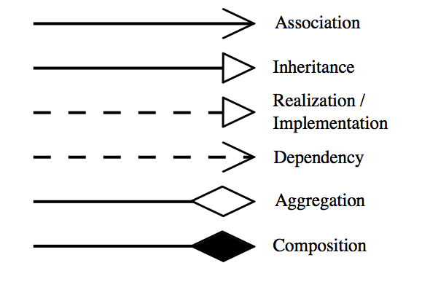
- Association: An association represents a bi-directional relationship between two classes. It indicates that instances of one class are connected to instances of another class. Associations are typically depicted as a solid line connecting the classes, with optional arrows indicating the direction of the relationship.
- Inheritance: Inheritance represents an "is-a" relationship between classes, where one class (the subclass or child) inherits the properties and behaviors of another class (the superclass or parent). The subclass inherits all the functions of the parent class, and the parent class has all the attributes, methods, and subclasses
- Realization/Implementation: Realization indicates that a class implements the features of an interface. It is often used in cases where a class realizes the operations defined by an interface.
- Dependency: A usage dependency (“uses”) relationship in a UML class diagram indicates that one class (the client) utilizes or depends on another class (the supplier) to perform certain tasks or access certain functionality. The client class relies on the services provided by the supplier class but does not own or create instances of it.
- Aggregation: Aggregation is a specialized form of association that represents a "whole-part" relationship (“has”). It denotes a stronger relationship where one class (the whole) contains or is composed of another class (the part). In this kind of relationship, the child class can exist independently of its parent class
- Composition: Composition is a stronger form of aggregation, indicating a more significant ownership or dependency relationship (“consists of”). In composition, the part class cannot exist independently of the whole class.

The top level diagram
There is one application running, being the python module oradio_control.py, which will initialize and create all instances necessary for the operation. The execute() function indicates that oradio_control.py is executed and running.
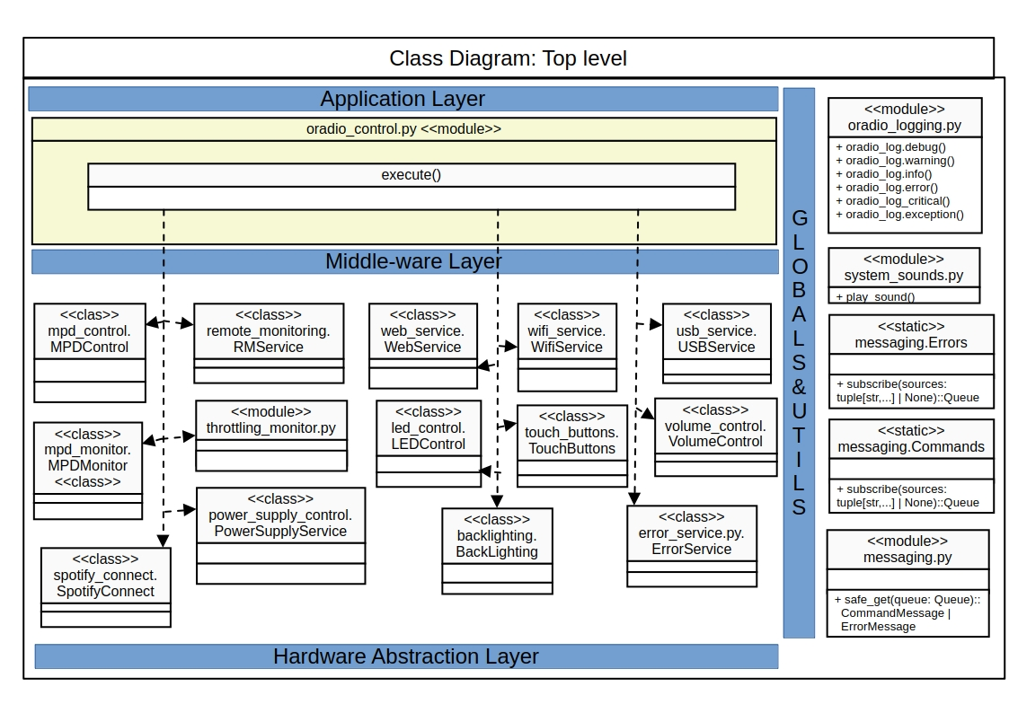
Most of the classes (stereotype <<class>>) will be instantiated during initialization phase of execution.
The throttled_monitor is globally instantiated, a monitoring thread will be started, to check the condition of the raspberrypi.
The global methods or functions are represented in the GLOBAL&UTILS layer, as these functions are public, being:
- oradio_log.xx()
- play_sound()
- subscribe_commands(), subscribe_errors(), publish_command(),publish_error()

Messaging

Non-Functional Requirements (NFR’s)
Messaging is categorized under reliability and extensibility . The key NFR’s are:
NFR-ident | Requirement | Reference
NFR-MSG-01 | For asynchronous inter-module communication a publish and subscribe messaging pattern shall be used..
NFR-MSG-02 | Publishers and subscribers shall operate independently, for flexibility and scalability
NFR-MSG-03 | The Publish and Subscribe systems shall use topic-based categorization. Subscribers express their interests by subscribing to specific topics. Publishers send messages to designated topics.
NFR-MSG-04 | A broker shall dispatch a published message towards the subscribers of this topic.
NFR-MSG-05 | There shall be a command-based topic, mainly used for controlling the system.
NFR-MSG-06 | There shall be an incident-based topic, mainly used for incident processing, such as errors and warnings
NFR-MSG-07 | A message shall be validated by broker, before publishing, to prevent incorrect messages being further processed.
NFR-MSG-08 | The broker will provide a separate queue for each subscriber: each published message must be copied to every subscriber’s queue, providing processing speed isolation. Each subscriber can operate at own speed: a slow or offline subscriber can build up its own backlog without delaying faster subscribers.
NFR-MSG-09 | A module which subscribes for a topic shall receives messages related to that topic.

Messaging introduction
xxxxxxx
the publish–subscribe (pub/sub) model is a messaging pattern where publishers send messages by topic, and subscribers receive only the messages they asked for. Publishers don’t need to know the subscribers’ identities, and an intermediary like a message broker routes messages to the right subscribers.
The publish-subscribe (pub/sub) model is a messaging pattern used in software architecture that facilitates communication between different components without them needing to know each other's identities. This model is particularly useful for asynchronous communication.

One of the main features of Pub/Sub systems is their flexibility and scalability - due to loose coupling between system components.
There are two coupling systems:
- Tight coupling describes system components that are highly dependent on each other. If one component malfunctions, it will affect the operation of other components, which can cause the entire system to crash. Also, updating one component may require updating dependent components, which creates system inflexibility and makes maintenance and scalability very difficult.
- Loose coupling, on the other hand, will not have such problems. The components of such systems are independent. In the case of a Pub/Sub system, the publisher, subscriber, and broker are independent entities with well-defined interfaces that interact with each other using a standardized protocol such as MQTT. This allows the development of each separate component without needing to change other components of the system.

Loose coupling
Publishers are loosely coupled to subscribers, and need not even know of their existence. With the topic being the focus, publishers and subscribers are allowed to remain ignorant of system topology. Each can continue to operate as per normal independently of the other. In the traditional tightly coupled client–server paradigm, the client cannot post messages to the server while the server process is not running, nor can the server receive messages unless the client is running. Many pub/sub systems decouple not only the locations of the publishers and subscribers but also decouple them temporally. A common strategy used by middleware analysts with such pub/sub systems is to take down a publisher to allow the subscriber to work through the backlog (a form of bandwidth throttling).

Scalability
Pub/sub provides the opportunity for better scalability than traditional client-server, through parallel operation, message caching, tree-based or network-based routing, etc. However, in certain types of tightly coupled, high-volume enterprise environments, as systems scale up to become data centers with thousands of servers sharing the pub/sub infrastructure, current vendor systems often lose this benefit; scalability for pub/sub products under high load in these contexts is a research challenge.
Outside of the enterprise environment, on the other hand, the pub/sub paradigm has proven its scalability to volumes far beyond those of a single data center, providing Internet-wide distributed messaging through web syndication protocols such as RSS and Atom. These syndication protocols accept higher latency and lack of delivery guarantees in exchange for the ability for even a low-end web server to syndicate messages to (potentially) millions of separate subscriber nodes.

When to Use
Use Pub/Sub Architecture when:
- Subscribers don’t need to know about each other, making the system more flexible and easier to scale.
- Pub/Sub helps you build systems that can grow easily. You can add more publishers or subscribers without disrupting the existing setup.
- If you want parts of your system to communicate without waiting for each other, Pub/Sub is a great option. Publishers can send messages without needing to wait for subscribers.
- This approach is perfect for event-driven systems. Publishers can send out events, and subscribers can respond to those events without being tightly linked together.
- With Pub/Sub, subscribers can change their interests at runtime. They can subscribe to different topics or types of messages, adding more flexibility to the system.

Messaging design choices
xxxxxx

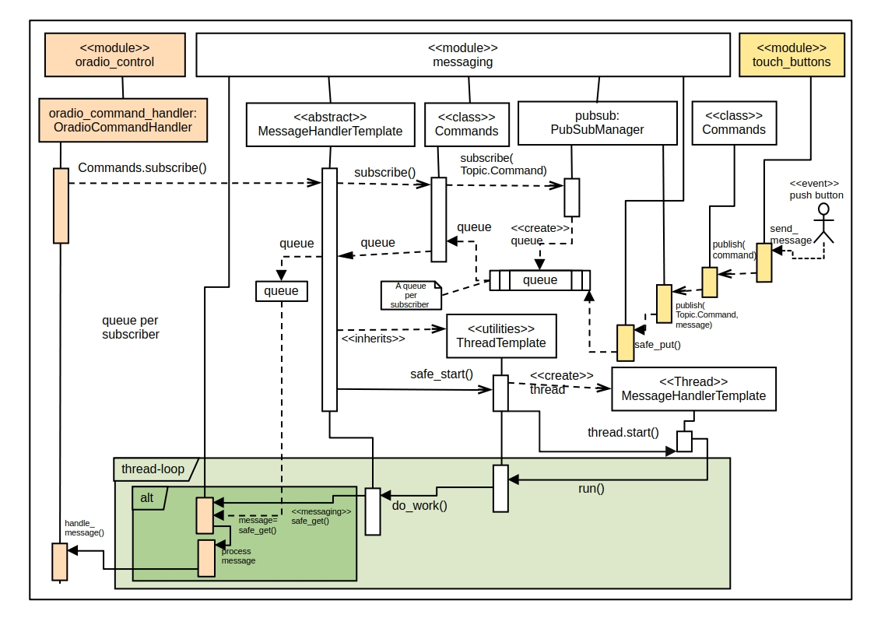Figure 1: Messaging for Commands Topic
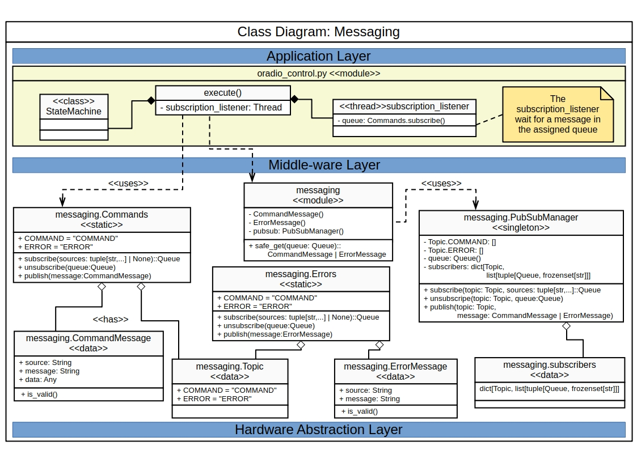
The messaging.py module provides services for the publish-subscribe model as inter-module communication. It is a messaging pattern where publishers send messages to a topic without knowing who the subscribers are, while subscribers express interest in specific topics to receive those messages. This model allows for asynchronous communication and decouples the components, enhancing scalability and flexibility in distributed systems.
The module has a public API to subscribe to a certain Topic or publish a message to a Topic. The defined Topics are:
- COMMAND: representing a command
- ERROR: representing an error code
The public API provides following methods:
- subscribe_commands(): subscribe to Message Topic, returning a message queue to monitor for new commands
- publish_command(message: CommandMessage): publish a command to COMMAND Topic
- subscribe_errors(): subscribe to Error Topic, returning a message queue to monitor for new errors
- publish_error(message: ErrorMessage): publish a command to ERROR Topic

Remote Monitoring Service
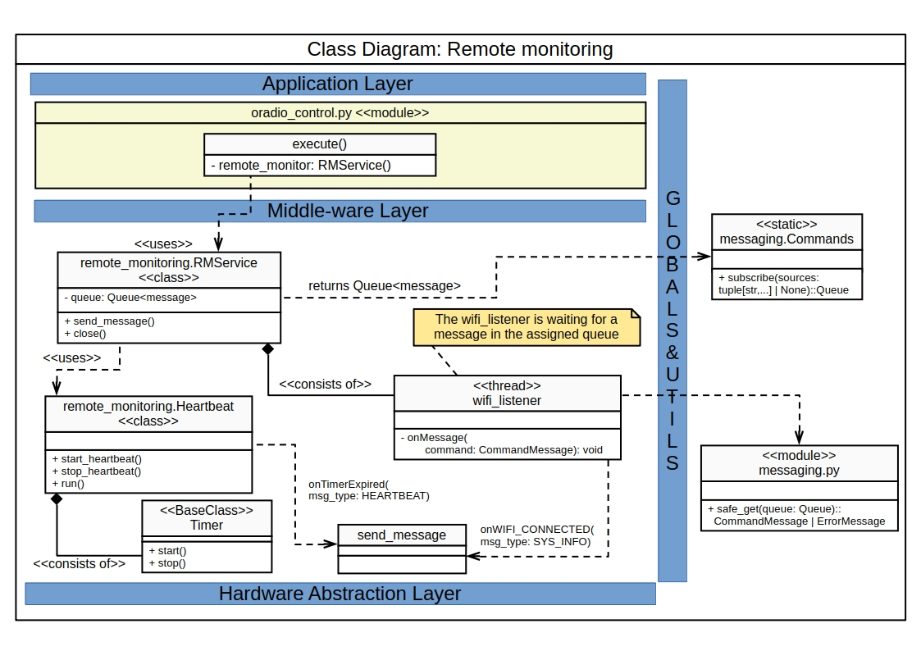
The Remote Monitoring Service maintains a connection with a Remote Server via Wifi. The class RMService() will be instantiated during initialization of oradio_control.py. The RMService class is depending on whether there is a WiFi connection available. So it initiates a thread <wifi_listener> that will listen to WiFi related commands, submitting a subscribe_commands(), which returns a message Queue. When WiFi is available is will send a SYS_INFO message to the server. A regular HEARTBEAT message is send to server as a keep-alive indication for the server

USB Service
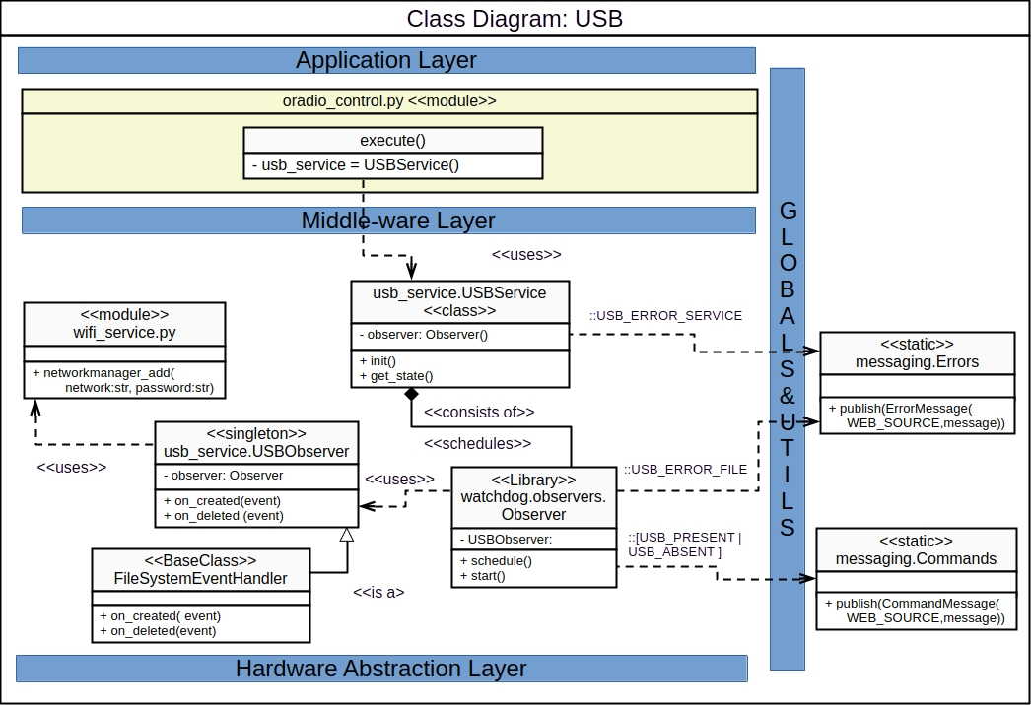

Wifi Service
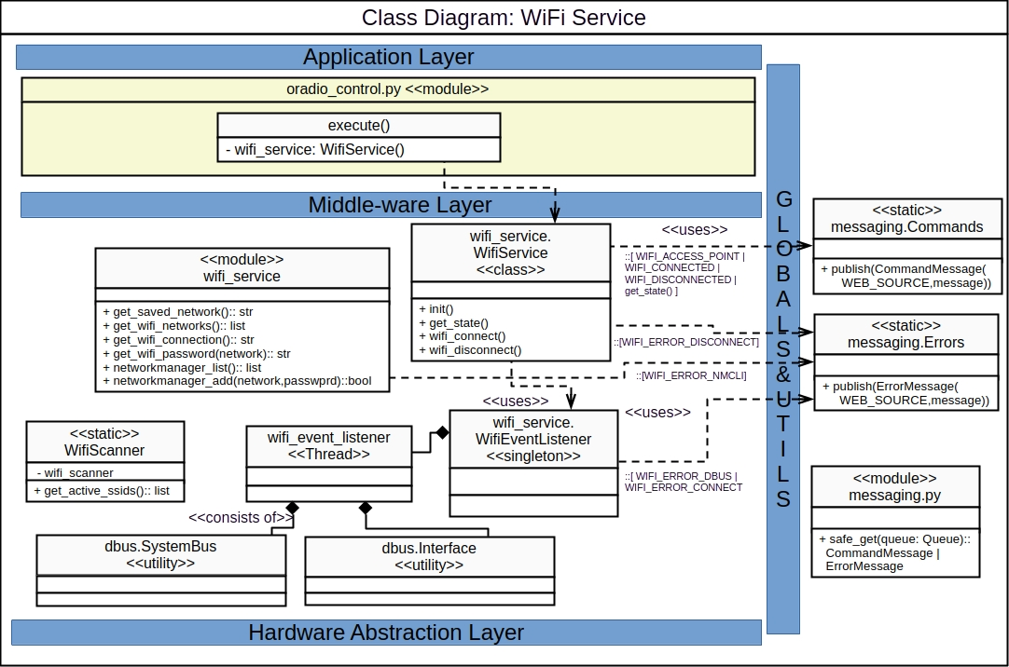

Logging

Non-Functional Requirements (NFR’s)
Logging is categorized under reliability and maintainability. The key NFR’s are:
NFR-ident | Requirement | Reference
NFR-LOG-001 | The system shall log all items with sufficient information to identify the moment, actual thread, code location and condition. | Formatter
NFR-LOG-002 | The application shall use Python’s standard logging framework. | Python-logger
NFR-LOG-003 | Logs shall use standardized levels (such as DEBUG, INFO, WARNING, ERROR, and CRITICAL),applying distinguishable color formats for each of the levels | Filters
NFR-LOG-004 | Debug-level logging shall be disabled in production unless temporarily enabled for diagnosis.
NFR-LOG-005 | The logging system shall not reduce application performance, causing noticeable delays in operation
NFR-LOG-006 | The application shall not terminate because a logging handler fails. | Queue
NFR-LOG-007 | Sensitive information, including passwords, authentication tokens, and personal data, shall not be written to logs.
NFR-LOG-008 | Logs shall be protected against unauthorized access and modification
NFR-LOG-009 | The logging system shall use an asynchronous processing mechanism, with enough processing capacity for the expected peak logging rate | Queue
NFR-LOG-010 | Log files shall use rotation based on size or time. | Rotate
NFR-LOG-011 | Rotated log files shall be removed according to the retention policy | Rotate
NFR-LOG-012 | The retention policy for a rotated log file is to keep the log file available for a duration of at least 5 days, for the lowest possible severity level.
NFR-LOG-013 | Each application module shall use the Oradio-specific logger. | Loggers
NFR-LOG-014 | The log outputs shall be at least to one console output and to one file output. | Queue
NFR-LOG-015 | Web-application (Uvicorn) logs shall be routed through the same logging system as for the Application logs | Queue
NFR-LOG-016 | Logging shall continue functioning if the Python log service is temporarily unavailable, using logging mechanism provided by RaspiOS. | Fallback
NFR-LOG-017 | The system shall define behavior when the configured logging system is not capable anymore to process a log-record. A fallback method should be used to prevent loosing the log-record | Fallback
NFR-LOG-018 | The system shall publish an incident report in case when a log-record is not delivered to the configured logging system | Monitoring
NFR-LOG-019 | The system shall write a Python trace-back upon fatal signals in Python execution, for diagnostic purposes | Faulthandler

Logging introduction
Here an overview on what the RaspiOS does on logging. The RaspiOS system offers a Journal service (systemd-journald) that collects and stores logging data. It creates and maintains structured, indexed journals based on logging information that is received from a variety of sources. This service is always present as part of the systemd.
Other logging services are the Rsyslog and Syslog-ng, but are optional:
- Rsyslog: when complex filtering and routing is required, compatibility with software requiring a traditional syslog daemon
- Syslog-ng (next-gen): offers a advanced filtering and has native support for structured logging formats
Python provides a built-in logging service for emitting log messages to track events and errors during execution. Python's logging.handlers module provides various handlers for directing log messages to different outputs, such as files, streams, or even remote servers.

Logging design choices
As we use Python, we should use the services offered by Python logging for all modules. It is designed to operate robustly in multi-threaded applications, Raspberry Pi hardware, and web applications (Uvicorn/FastAPI).
The module log_service.py will provide a wrapper around the Python built-in logging services, with pre-configured Logger and Handlers.
For all Python based logging the generic base class (logging.Handler) is used. Processing of the logging to the configured output ( file, terminal, or syslog) may take considerable time. A queue-based handler should be used (QueueHandler): meaning that an emitted log-record is put on log_queue and consumed by a logging listener (QueueListener). In this way the logging output can not block the main application. The application only needs to enqueue the record quickly, while the listener performs the slower output work in the background.
Another choice is to integrate the logs of the Web-Server (Uvicorn/FastAPI). The Web-server has its own loggers defined. Which is not convenient, as we want to have all the logging to the logger defined in log_service. These log-records are being re-routed to QueueHandler used in log_service.

See the #Logging activity diagram below for more details on design.

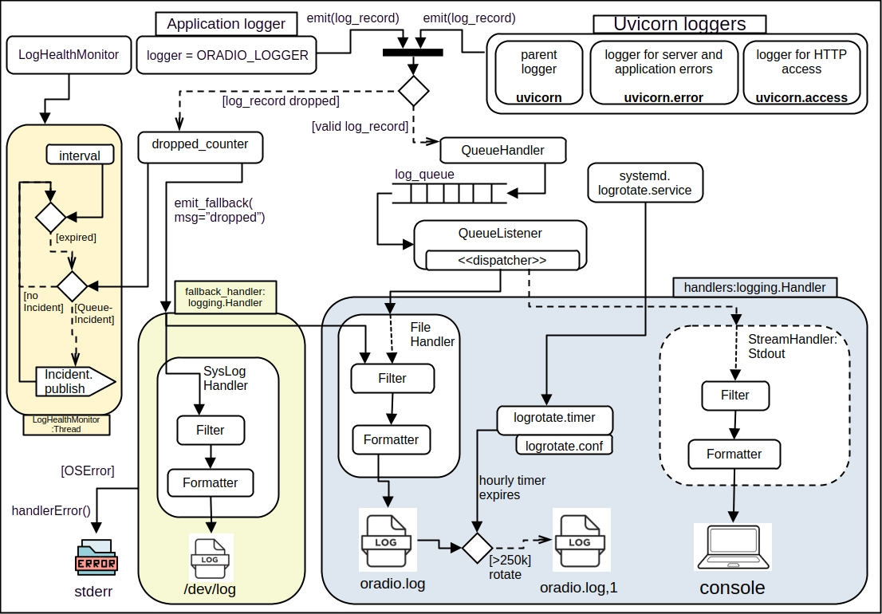Figure 2: Logging activity diagram

Loggers
In the Oradio there are two loggers:
- The ORADIO_LOGGER as Application logger to emit log records.
- The Uvicorn loggers used by the uvicorn server to emit log records through specific named loggers, being:
  - uvicorn.error: is used during startup, shutdown, server errors, and application
  - uvivorn.access: http access logs
  - uvicorn: the parent logger as a shared aggregation point for the child loggers

There are 2 handlers configured for different outputs:
- a StreamHandler sending log to the standard output (stdout) as console output
- a FileHandler sending output to LOGGING_PATH/oradio.log.

Queue handling
To separate the logging output from the application logger, a queue is used. This prevents the logging output from blocking the main application. A QueueHandler and QueueListener are used:
- The QueueHandler receives log records from the python modules and from the uvicon loggers and places them into a queue.
- The QueueListener reads the log record from the queue in a background thread and distributes them to the configured output handlers

Fallback loggers
In case of errors with the queue-based logging, and the Application logging was not performed, a fallback mechanism should be provided to not lose the log-record. The fallback handler should be independent of the Application logger handlers.
During emit of a log_record the QueueHandler will check if putting the log_record on the log_queue was successful or not. If not it will be recorded as a dropped record. The log_record will be emitted to the configured fallback handlers. There are 2 fallback handlers configured:
- One handler uses the already configured FileHandler, for logging to the oradio.log file located at ORADIO_LOG_PATH. Now the QueueHandler is bypassed, and it tries to output the log_record directly to the oradio.log.
- Other handler is a SysLogHandler sending the log_record to the system’s central syslog server.

In case the fallback handlers can not process the log_record, the log_record will be send to the stderr file, as a last resort.

LogHealthMonitor
As the log_service module may encounter issues during logging, such as a dropped log_record, it is necessary to publish these issues as incidents.
The log_service module is not designed to publish incidents. The incident handler requires the log_service also. So prevent circular imports and recursive logging's when incidents are reporting in the log_service module, this LogHealthMonitor module will monitor issues related to log_service module and report them as incidents.
It will monitor when a log_record is dropped and report it as an incident.

Handlers: Filter and Formatter
Each logging handler provides a filter to decide whether a log record should be processed. The formatter will format the log message text according the defined Oradio layout

Linux Logrotate utility
To prevent log files from consuming too much disk space, the OS-utility Logrotate() is used. The Logrotate() utility takes care for automatically rotating, compressing , and removing old logs to save disk space and keep the system organized. The utility works by periodically "rotating" log files: moving the current log to a timestamped archive file and creating a fresh log file for new entries.
Logrotate() uses a hierarchical configuration system with global defaults and service-specific overrides. The main configuration file is /etc/logrotate.conf, which sets system-wide defaults and includes service-specific configurations from /etc/logrotate.d/. Settings in service-specific files override global defaults.
The service-specific configuration for oradio is placed in /etc/logrotate.d/oradio, where the attributes for the oradio.log file are configured, such as:
- location of the log file
- size of logfile
- number of rotate files
- using compressing on the file
The Logrotate() service is triggered periodically with a timer specific configuration for oradio: in /etc/systemd/system/logrotate.timer.d/oradio.conf,which is configured for an hourly log file check.
When the logrotate.timer expires, systemd starts the associated logrotate.service, reads the /etc/logrotate.conf and the service-specific configuration files under /etc/logrotate.d/. Here oradio-specific config file is located. The rules defined in the config file will be checked and processed

Class diagrams

log_service class diagram
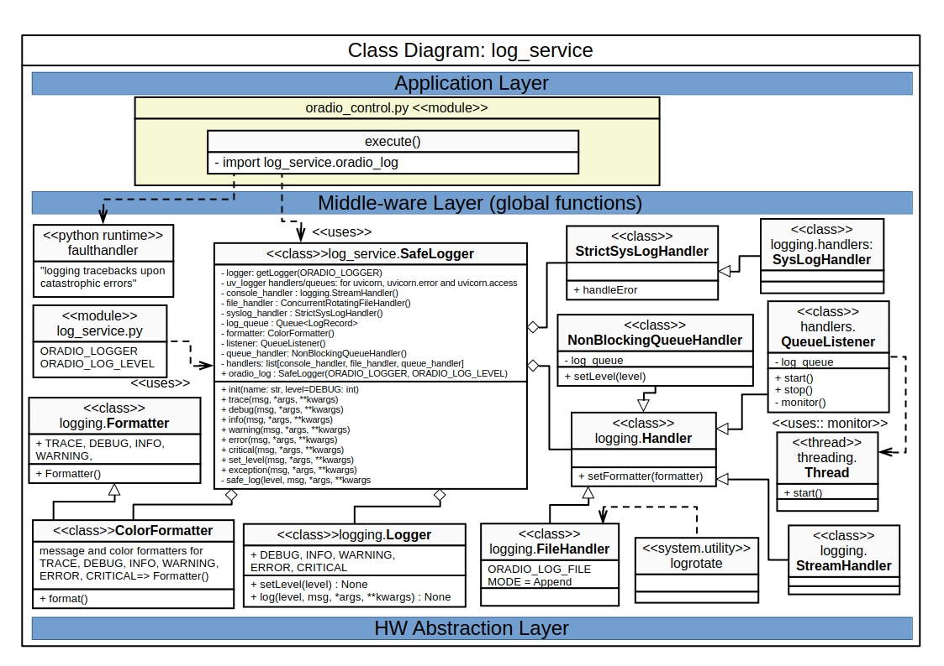Figure 3: log_service class diagram

SafeLogger class
The main class is the SafeLogger which provides a wrapper for application logging. In the log_service a public instance oradio_log is created, which can be used in the applications to call the logging methods:
- oradio_log.trace(): log a message with TRACE(=5) severity level
- oradio_log.debug(): log a message with DEBUG(=10) severity level
- oradio_log.info(): log a message with INFO(=20) severity level
- oradio_log.warning(): log a message with WARNING(=30) severity level
- oradio_log.error(): log a message with ERROR(=40) severity level
- oradio_log.critical(): log a message with CRITICAL(=50) severity level
- oradio_log.set_level(): set the logging level.
The SafeLogger <<class>> is an aggregation of:
- logging.Logger <<class>>: representing a logging channel, which gets a name called ORADIO_LOGGER. The SafeLogger wrapper will inherits the methods for setLevel(), info(), debug(), warning(), error(), and critical()
- logging.Handler <<class>>: Handler instances dispatch logging events to specific destinations, such as:
  - console output, which is a subclass of the superclass logging.StreamHandler. which writes (formatted) log-records to a stream
  - logging to a log file, which is a subclass of the superclass logging.FileHandler. which writes (formatted) log-records to a disk file.
- StrictSysLogHandler <<class>>: is a subclass of the superclass logging.Handler.SysLogHandler, which writes (formatted) log-records to a syslog server or location.
- ColorFormatter <<class>>: is a subclass of the superclass logging.Formatter, which adds ANSI based colors to messages, depending on the log level
- The public instance oradio_log of the class SafeLogger will be imported from log_service module during initial execution of oradio_control.py module.
- The faulthandler will be enabled during initial execution.

faulthandler
It is important to collect information upon e.g. crashes in Python. The faulthandler helps in diagnosing of such crashes, by writing a traceback to the standard error device
The Python faulthandler is included during import of the logging module. When enabled it provides tools for diagnosing Python interpreter crashes and fatal signals. It will be registered to the Python Interpreter. When a catastrophic signal such as SIGSEGV or SIGABRT occurs, the fault handler prints a traceback to sys.stderr instead of leaving only an OS-level crash message. The stderr output is redirected to a file. It is implemented in C so it remains functional even when the interpreter is in a corrupted state.

StrictLogHandler
The StrictLoghandler ( or child) inherits from the superclass SysLogHandler, and reuses all attributes and methods from superclass (or parent). In Python’s logging framework, when emit() (or the handler’s internal send) fails, the logging system usually calls handleError(). In the standard logging.Handler implementation, handleError() generally does not raise to the caller. It may print to stderr (depending on config) and then continue. That means your code can’t reliably detect “syslog is broken” at startup. The StrictLogHandler subclass overrides handleError() to raise an OSError.

Queue
A queue is essential to separate the actual writing of a log-record to its output, from the application log-request, to prevent holding up the application. Following classes are used:
- NonBlockingQueueHandler: Inherits from QueueHandler and puts a log record on the queue, and also counts and reports when a record is dropped (queue full)
- QueueListener: a class that consumes log records from a queue and dispatches to one of the log handlers

log_monitor class diagram

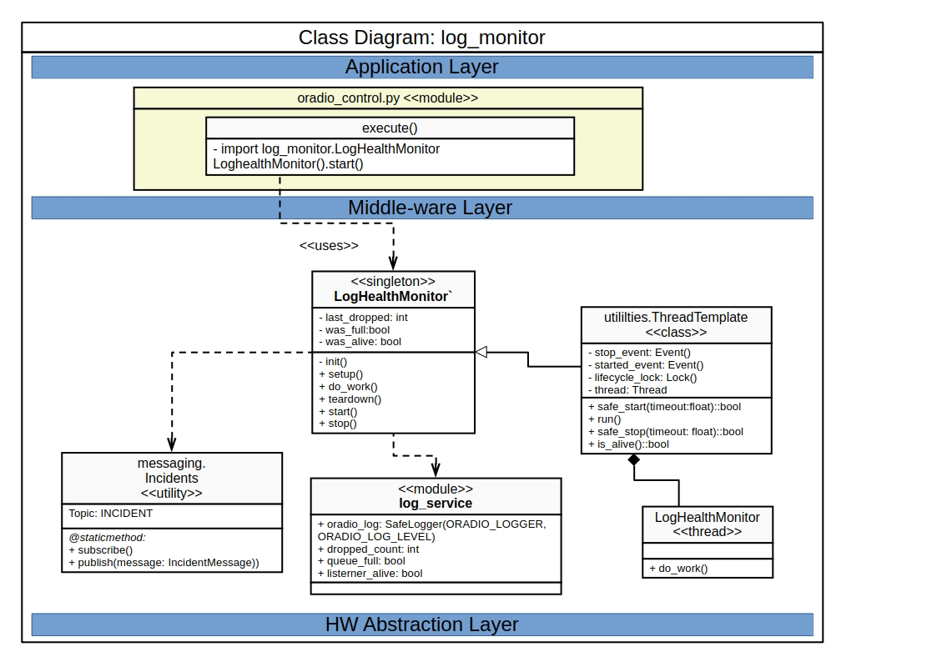Figure 4: log_monitor class diagram

Reporting incidents is not possible in the log_service module, as incident reporting also requires the logging functionality within the log_service. This would lead to cyclic or recursive logging.
The LogHealthMonitor class will monitor the dropped log-records in a LogHealtMonitor thread. Upon a dropped log-record in log_service the do_work() method in the thread will publish an incident using the messaging.Incident utility

The Logical view: State diagrams

Maincontrol state
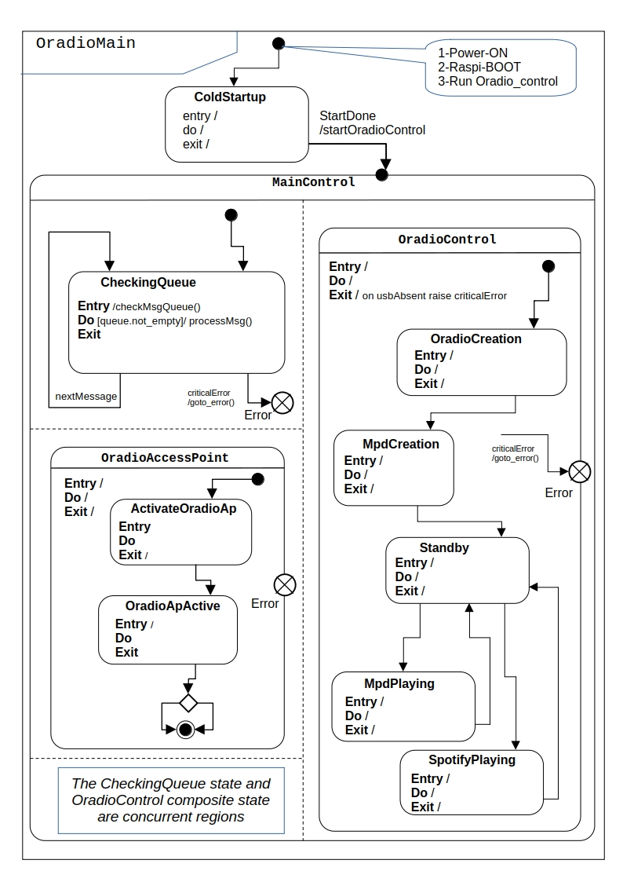
Description: xxxxxx

Oradio Control States
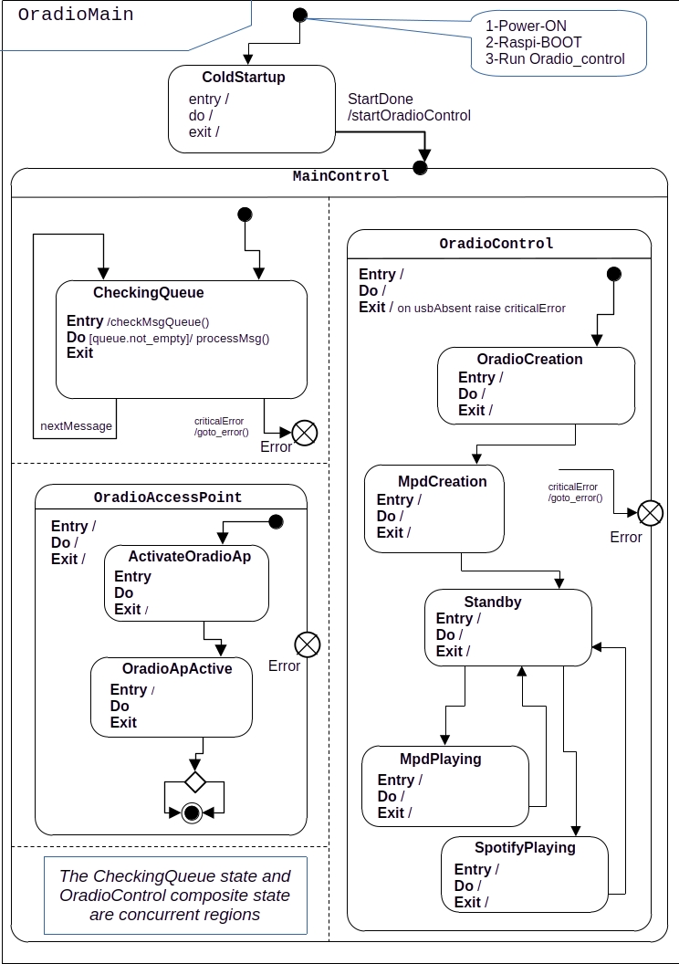
Description:xxx

Access Point state control
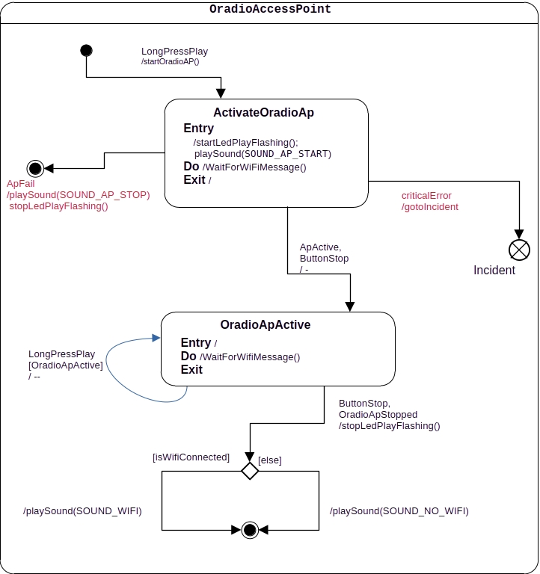

PluginManager State control
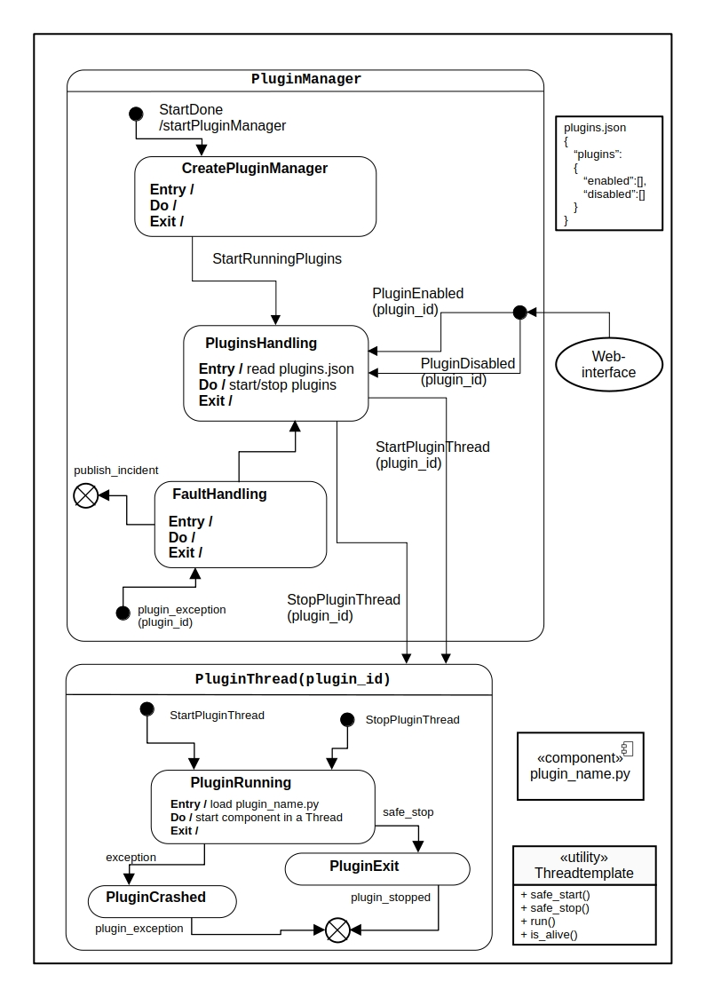
The plugins manager is responsible for controlling the plugins. The plugins are used to dynamical extend the functionality of the standard Oradio.
The standard Oradio is supporting:
- Touch button handling
- Led indications
- System sound for announcements
- Default music player: MPD
- Internet access via WiFi
- Web-interface to configure the Oradio
As an example the Oradio could be extended with a Spotify service. This service will be offered as plugin. The plugins manager will start/run a plugin dynamically when it is enabled, as a Thread. So it each plugin runs in its own execution context. If a plugins has a fault the PluginsManager gets an exception, so the Thread can be removed.
The plugin framework provides an abstract base class for initialization, execution and cleanup of the plugin.

The Physical view: Component diagrams

OS Service

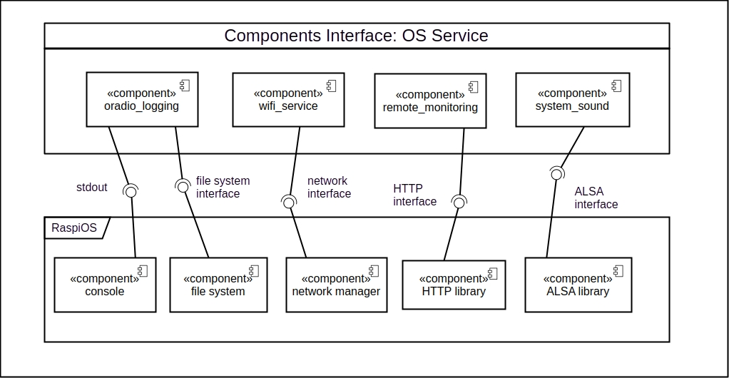

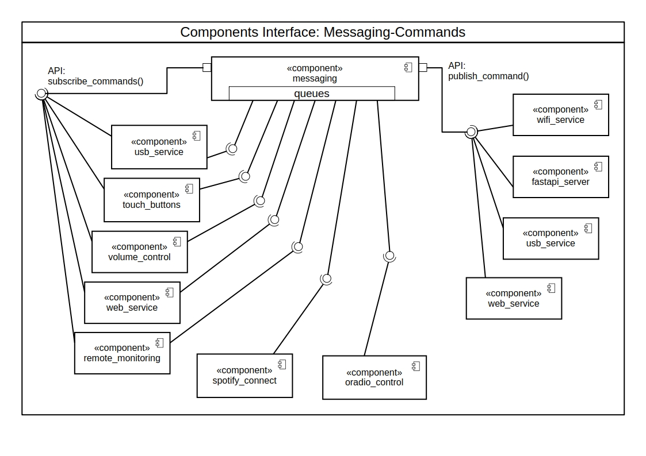
Messaging (Commands)

The messaging component interfaces to subscribers are queues. Each subscribers gets an assigned Command queue upon the provided API:subscribe_commands(). The Command queue can be monitored by the subscriber to check for new commands.
Commands can be published by publishers with the API:publish_commands(). The messaging component will distribute the published commands to all subscribers via their assigned queues.

Music Players

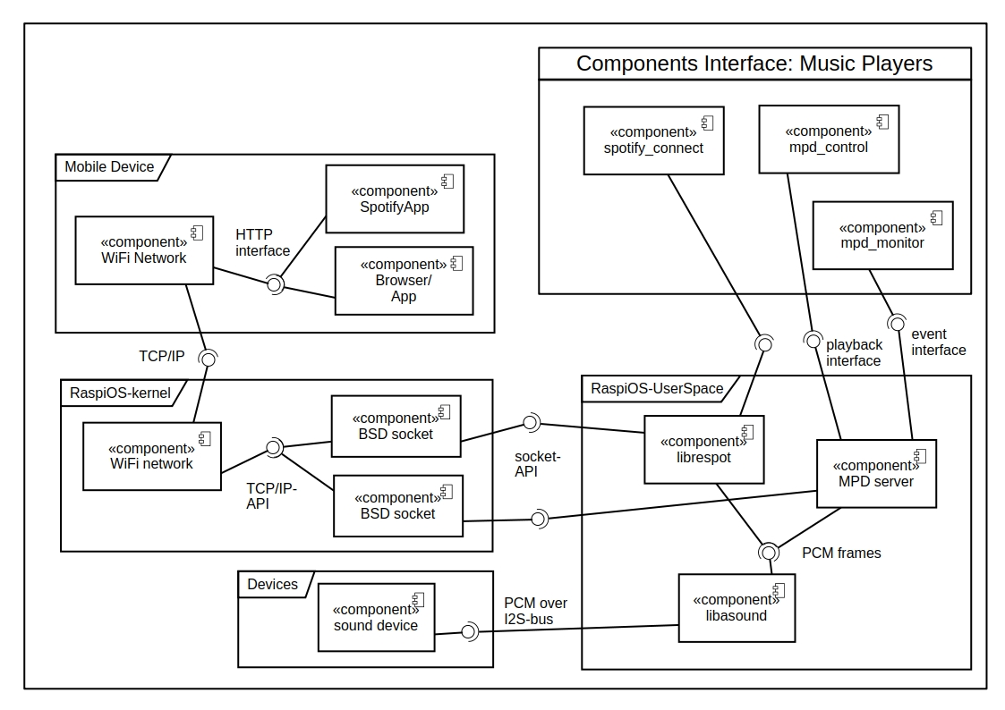

GPIO components

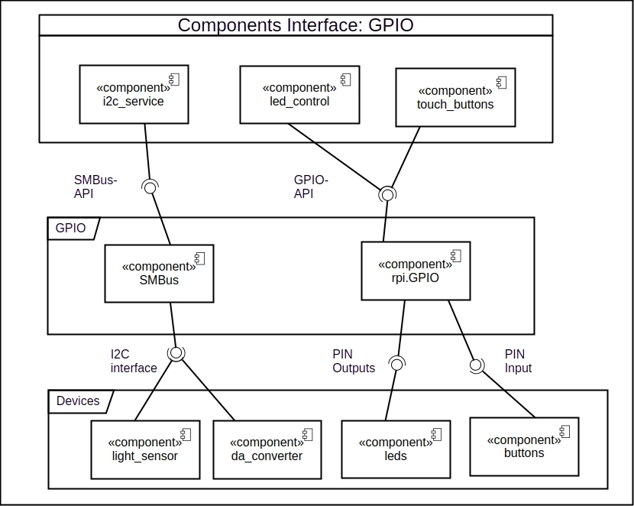

The Process view: Sequence diagrams

Messaging
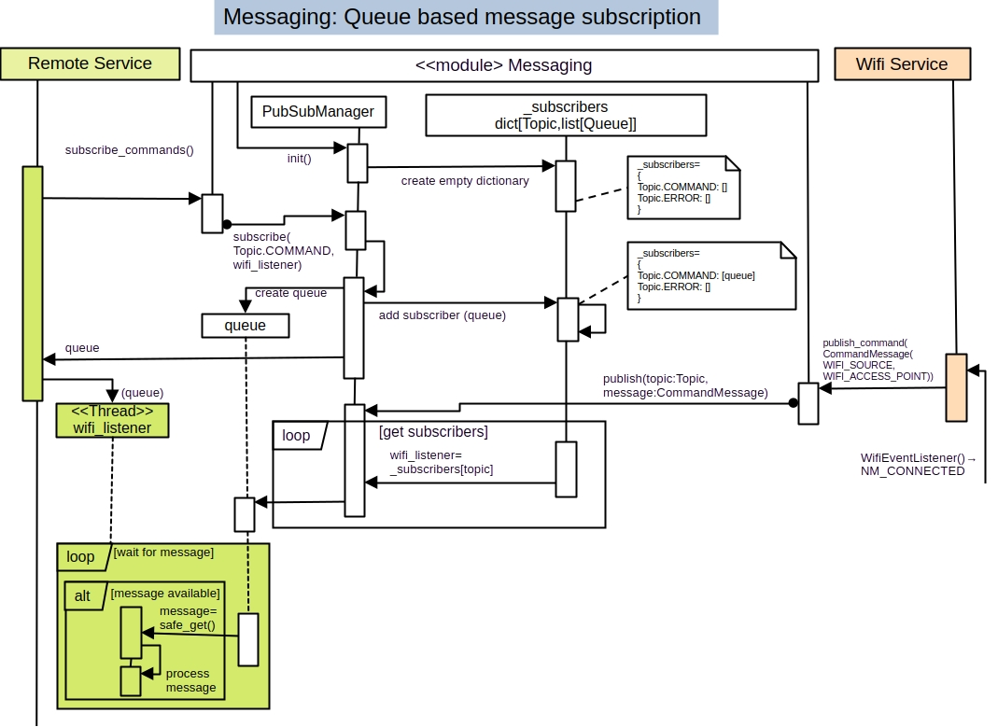

The scenario view: use case diagrams

